Match the photo to the correct person:

1. Revolutioner

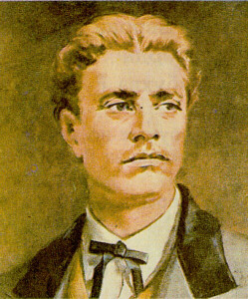

a. Blagovest Sendov

b. Petko Karavelov

c. Vasil Levski

d. Ivan Vazov

Answer: c

2. Artist

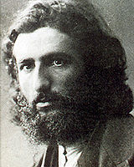

a. Vladimir Dimitrov

b. Zlatyo Boyadzhiev

c. Tsanko Lavrenov

d. Margarit Tsanev

Answer: a

3. World Record Holder in High Jump



a. Maria Petrova

b. Stefka Kostadinova

c. Hristo Stoichkov

d. Kubrat Pulev

Answer: b

4. Singer, she sang the song "Izlel e Delyu Haydutin", part of the Voyager Golden Record selection of music included in the two Voyager spacecraft launched in 1977

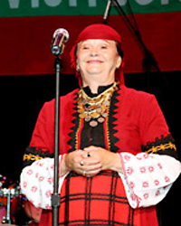

a. Lili Ivanova

b. Margarita Hranova

c. Valya Balkanska

d. Maria Ilieva

Answer: c

5. Politician, the end of the 19th century

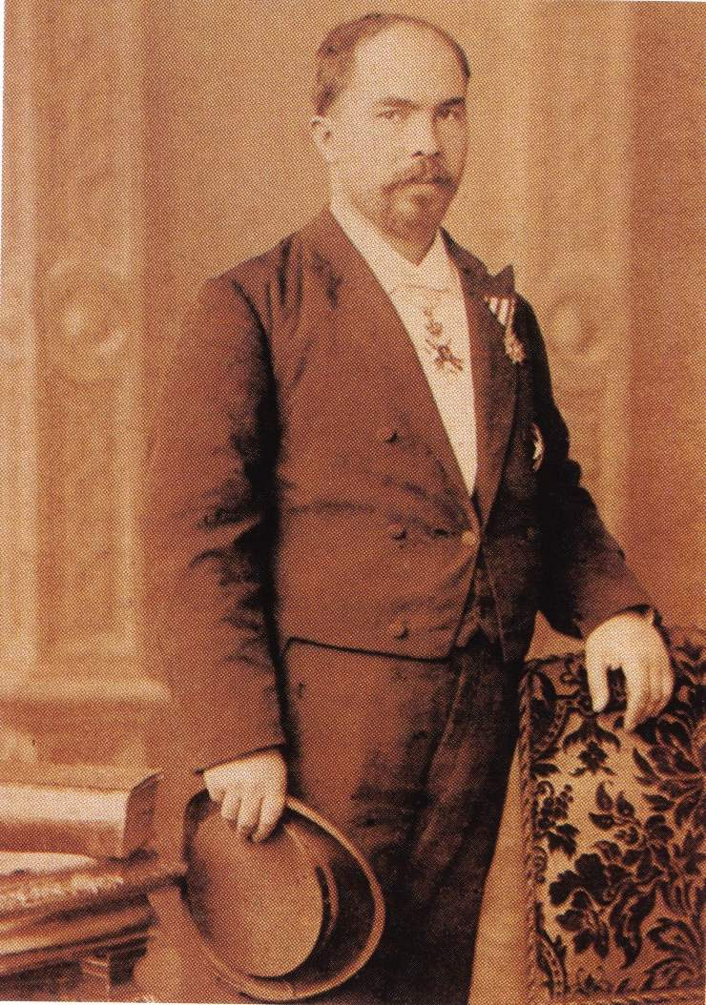

a. Petko Karavelov

b. Konstantin Stoilov

c. Alexander Malinov

d. Stefan Stambolov

Answer: d

**Sources:**

**Vasil Levski**

<http://bg.wikipedia.org/wiki/%D0%92%D0%B0%D1%81%D0%B8%D0%BB_%D0%9B%D0%B5%D0%B2%D1%81%D0%BA%D0%B8>

<http://www.spge-bg.com/_data2/pages/projects/itcomel_uk/levski.html>

**Vladimir Dimitrov**

<http://bg.wikipedia.org/wiki/%D0%92%D0%BB%D0%B0%D0%B4%D0%B8%D0%BC%D0%B8%D1%80_%D0%94%D0%B8%D0%BC%D0%B8%D1%82%D1%80%D0%BE%D0%B2_%E2%80%93_%D0%9C%D0%B0%D0%B9%D1%81%D1%82%D0%BE%D1%80%D0%B0>

**Stefka Kostadinova**

<http://bg.wikipedia.org/wiki/%D0%A1%D1%82%D0%B5%D1%84%D0%BA%D0%B0_%D0%9A%D0%BE%D1%81%D1%82%D0%B0%D0%B4%D0%B8%D0%BD%D0%BE%D0%B2%D0%B0>

**Valya Balkanska**

<http://horo.bg/index.php?menunode=265&show=material&materialid=2864>

**Stefan Stambolov**

<http://alexanderherzdorf.blog.bg/history/2012/06/06/bylgariia-po-vremeto-na-stambolov.964626>